**DBMS PROJECT**

**Group Members:**

**Ali Muhammad (11344)**

**Muhammad Nomir (11330)**

**ER Diagram:**

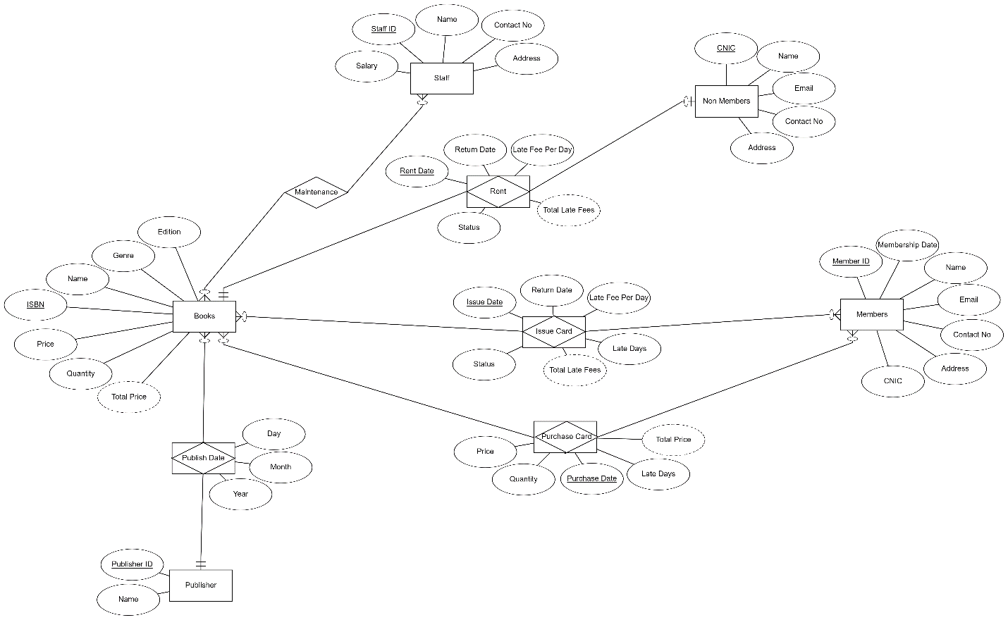

**Internal Schema:**

**Books = {**ISBN, Name, Genre, Edition, Price, Quantity, Publisher_ID**}**

**Members = {**Member_ID, Name, Email, Contact No, Address, CNIC, Membership Date**}**

**Issue Card = {**(ISBN, Member_ID, Issue Date), Return Date, Late Fee Per Day, Late Days, Status**}**

**Purchase Card = {**(ISBN, Member_ID, Purchase Date), Price, Quantity**}**

**Staff = {**Staff_ID, Name, Contact No, Address, Salary**}**

**Maintenance = {**ISBN,Staff_ID**}**

**Non-Members = {**CNIC, Name, Email, Contact No, Address, ISBN**}**

**Rent = {**(ISBN, CNIC,Rent Date), Return Date, Late Fee Per Day, Late Days, Status**}**

**Publisher = {**Publisher_ID, Name**}**

**Publish Date = {**(ISBN,Publisher_ID), Day, Month, Year**}**

**Normalization:**

**Publishers Table:**

**Publisher = {**Publisher_ID, Name**}**

**1NF:**

Already In 1NF

**2NF:**

Single primary key so in 2NF

**3NF:**

No transitivity so in 3NF

**BCNF:**

All primary keys are candidate

Table is normalized

**Books Table:**

**Books = {**ISBN, Name, Genre, Edition, Price, Quantity, Publisher_ID**}**

**1NF:**

Already In 1NF

**2NF:**

Single primary key so in 2NF

**3NF:**

No transitivity so in 3NF

**BCNF:**

All primary keys are candidate

Table is normalized

**Publish Date Table:**

**Publish Date = {**(ISBN,Publisher_ID), Day, Month, Year**}**

**1NF:**

Already In 1NF

**2NF:**

No partial dependency in composite primary keys so in 2NF

**3NF:**

No transitivity so in 3NF

**BCNF:**

All primary keys are candidate

Table is normalized

**Members Table:**

**Members = {**Member_ID, Name, Email, Contact No, Address, CNIC, Membership Date**}**

**1NF:**

Already In 1NF

**2NF:**

Single primary key so in 2NF

**3NF:**

No transitivity so in 3NF

**BCNF:**

All primary keys are candidate

Table is normalized

**Issue Table:**

**Issue Card = {**(ISBN, Member_ID, Issue Date), Return Date, Late Fee Per Day, Late Days, Status**}**

**1NF:**

Already In 1NF

**2NF:**

No partial dependency in composite primary keys so in 2NF

**3NF:**

No transitivity so in 3NF

**BCNF:**

All primary keys are candidate

Table is normalized

**Purchase Table:**

**Purchase Card = {**(ISBN, Member_ID, Purchase Date), Price, Quantity**}**

**1NF:**

Already In 1NF

**2NF:**

No partial dependency in composite primary keys so in 2NF

**3NF:**

No transitivity so in 3NF

**BCNF:**

All primary keys are candidate

Table is normalized

**Non-Members Table:**

**Non-Members = {**CNIC, Name, Email, Contact No, Address, ISBN**}**

**1NF:**

Already In 1NF

**2NF:**

Single primary key so in 2NF

**3NF:**

No transitivity so in 3NF

**BCNF:**

All primary keys are candidate

Table is normalized

**Rent Table:**

**Rent = {**(ISBN, CNIC,Rent Date), Return Date, Late Fee Per Day, Late Days, Status**}**

**1NF:**

Already In 1NF

**2NF:**

No partial dependency in composite primary keys so in 2NF

**3NF:**

No transitivity so in 3NF

**BCNF:**

All primary keys are candidate

Table is normalized

**Staff Table:**

**Staff = {**Staff_ID, Name, Contact No, Address, Salary**}**

**1NF:**

Already In 1NF

**2NF:**

Single primary key so in 2NF

**3NF:**

No transitivity so in 3NF

**BCNF:**

All primary keys are candidate

Table is normalized

**Maintenance Table:**

**Maintenance = {**ISBN,Staff_ID**}**

**1NF:**

Already In 1NF

**2NF:**

Single primary key so in 2NF

**3NF:**

No additional attributes so no transitivity can occur so in 3NF

**BCNF:**

All primary keys are candidate

Table is normalized